ComponentsWillUnmount using useEffects ->

Banner.js

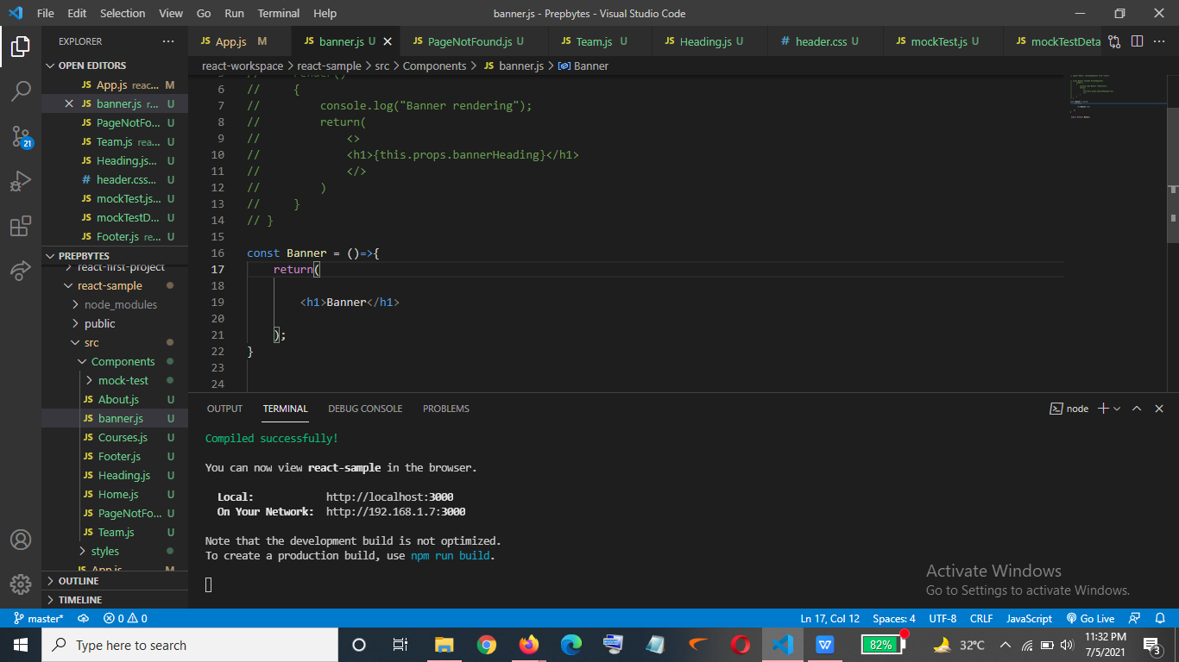

Output->

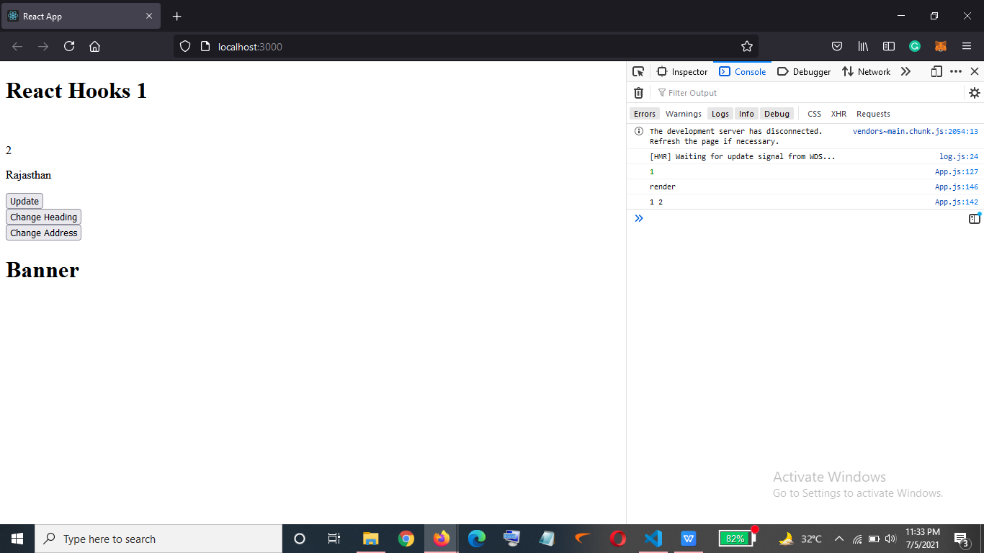

On the click of the button I want to remove the banner heading->

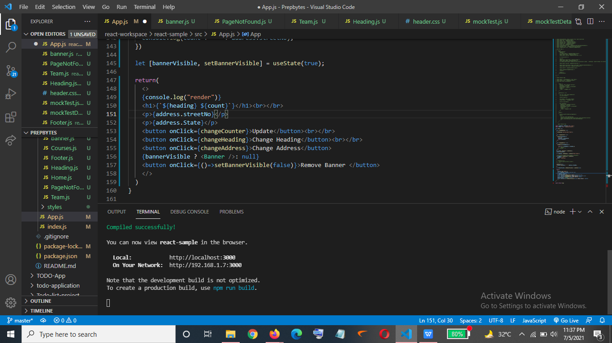

Output->

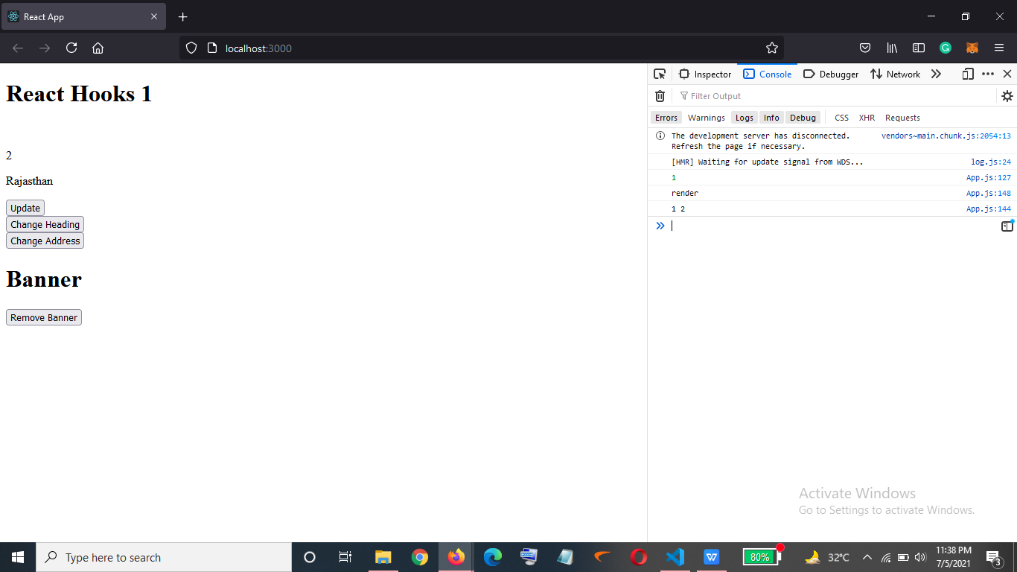

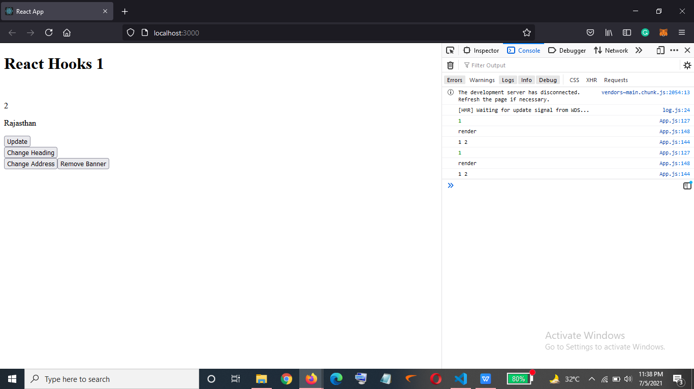

Returning a function inside banner.js

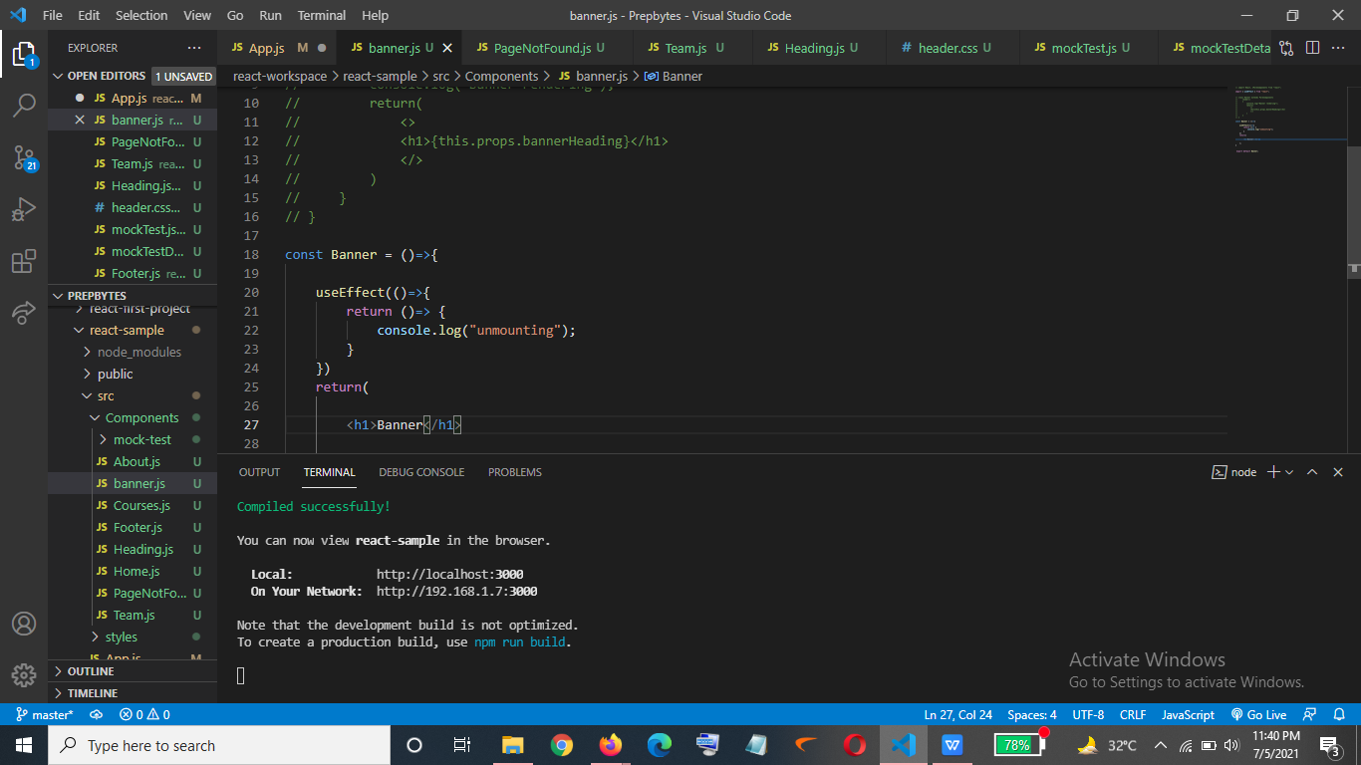

Output->

AS I see that function is been returned again and again after any update is happening so we don’t want that

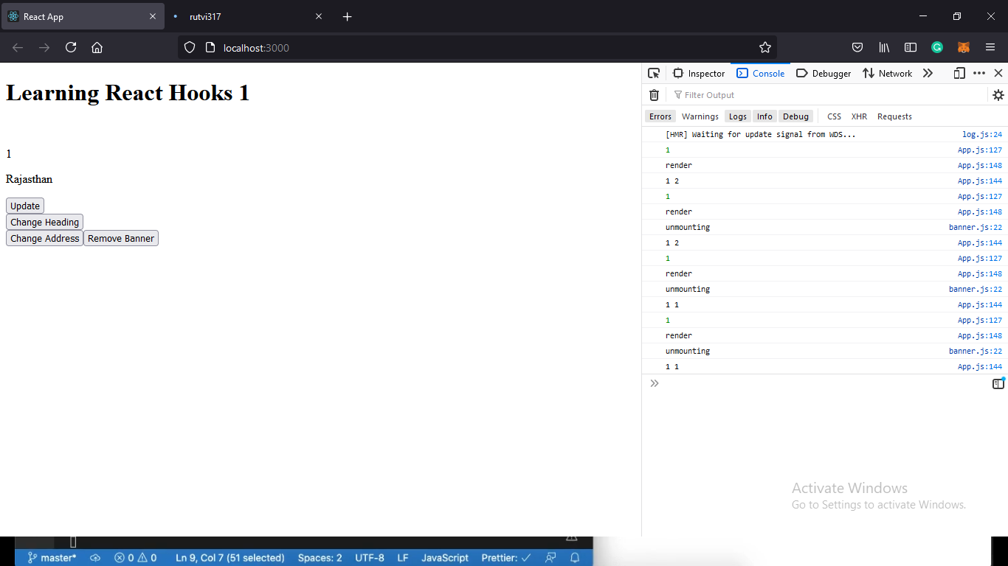

In order to achieve that I will have to pass an empty array->

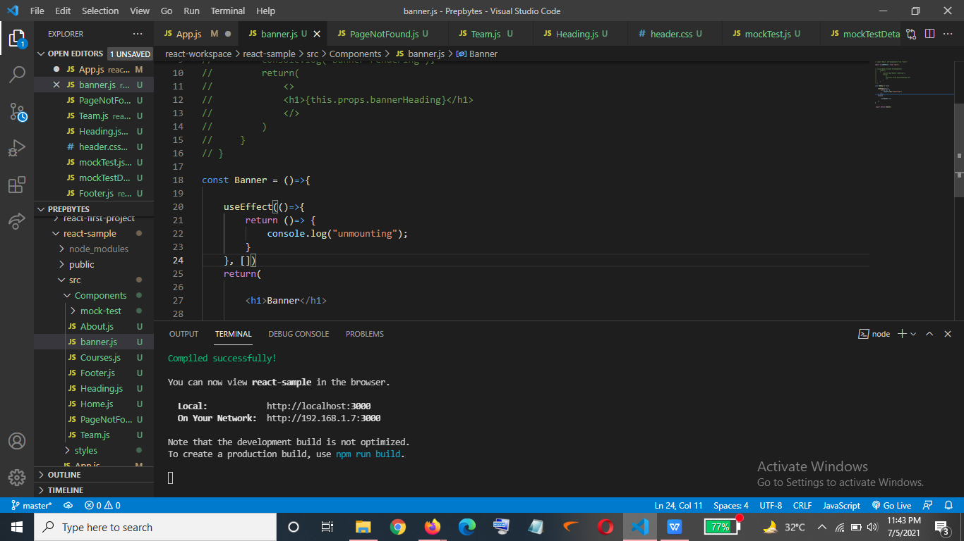

Output->

So now the unmounting method will only be called when banner heading is been removed from the screen.

